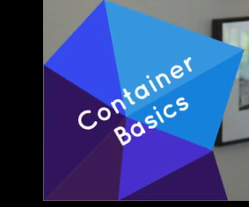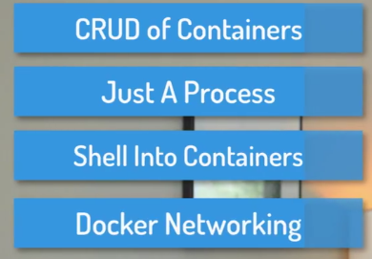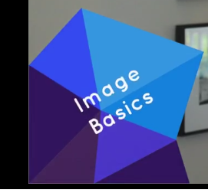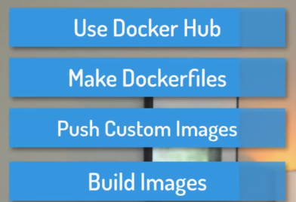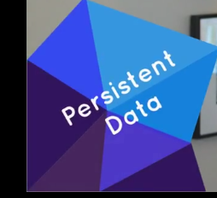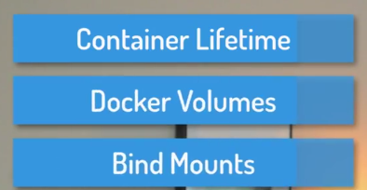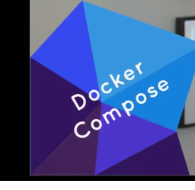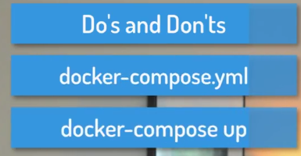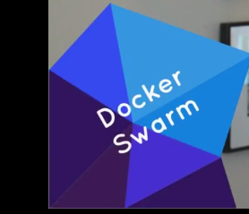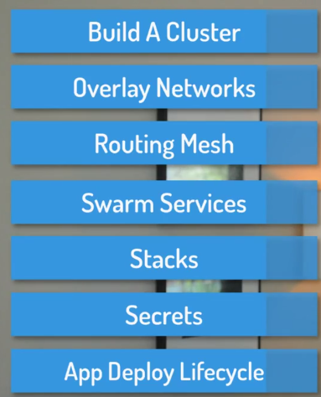

<https://github.com/bretfisher/udemy-docker-mastery>

chat.dockermastery.com

<https://dockermastery.slack.com/>

**Install:**

🡪Pro and Enterprise editions of Windows 10 (with latest update rollups).

["Docker for Windows" from the Docker Store](https://www.docker.com/docker-windows).

🡪**Installing on Windows 7, 8, or 10 Home Edition**

Unfortunately, Microsoft's OS features for Docker and Hyper-V don't work in these older versions, and "Windows 10 Home" edition doesn't have Hyper-V, so you'll need to [install the Docker Toolbox](https://www.docker.com/products/docker-toolbox), which is a slightly different approach to using Docker with a VirtualBox VM. This means Docker will be running in a Virtual Machine that sits behind the IP of your OS, and uses NAT to access the internet.

**NOTE**: For all examples that use http://localhost , **you'll need to replace with** <http://192.168.99.100>

**-🡪Installing on Linux**

**Do *not* use your built in default packages like apt/yum install docker.io** because those packages are old and not the Official Docker-Built packages.

I prefer to use the Docker's automated script to add their repository and install all dependencies: curl -sSL https://get.docker.com/ | sh

[play-with-docker.com](http://play-with-docker.com/) -🡪 4hrs

Editors:

Good free ones are GitHub's [Atom](https://atom.io/), Microsoft's [Visual Studio Code](https://code.visualstudio.com/), or even [VIM](http://spacevim.org/) if you're into shell-based editors.

🡪There may be mentions of 1.12  and 1.13  in this course, which were the two versions before 17.03 . 1.

13.1  is actually the same features as 17.03.0 , so if you see 1.13  on my screen recording and 17.04  or similar in your CLI, it's fine!

**🡪Big News:** **Docker versioning, release cycle, and product name has changed, but features haven't.** [Full details are here](https://blog.docker.com/2017/03/docker-enterprise-edition/), but my commentary on important highlights are below:

* **Docker Engine** (the free one we all know and love) **is now Docker CE** (Community Edition). Notice the drop of the word Engine. I suspect we can just call this Docker now. It includes the cli client and backend daemon/service and api (just like it did before). You can get it the same ways as before.
* **Docker Data Center is now Docker EE** (Enterprise Edition) and adds additional [paid products and support](https://store.docker.com/search?offering=enterprise&type=edition) on top of Docker in three pricing tiers.
* These changes don't affect Docker Compose or Docker Machine.
* **Docker's version is now YY.MM  based**, using the month of its expected release, and the first one will be 17.03.0 , which is "the first point release" of the 17.03  release. If any bug/security fixes are needed to that release, the first update will be 17.03.1  etc.
* We now have two release tracks (called variants) "Edge" and "Stable".
  + Edge is released monthly and supported for a month.
  + Stable is released quarterly and support for 4 months.
  + You can extend Stable's support and backported fixes through a [Docker EE subscription](https://store.docker.com/search?offering=enterprise&type=edition).

# 02-creating-and-using-containers-like-a-boss

1. 009-check-our-docker-install-and-config:

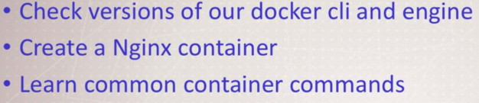

Docker Engine is Docker daemon (runs in background) or docker service (Windows). It’s core of docker.

Commands we run talks to daemon over API

1. 010-starting-a-nginx-web-server:

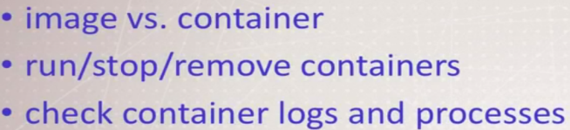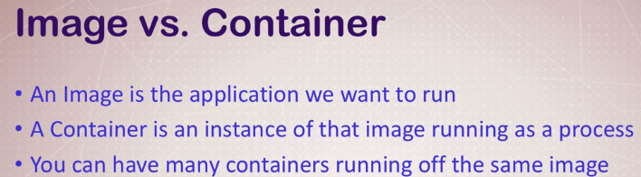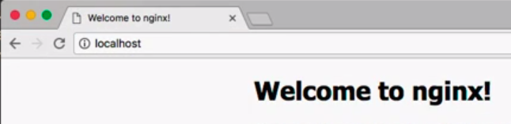

1. 011-debrief-what-happens-when-we-run-a-container

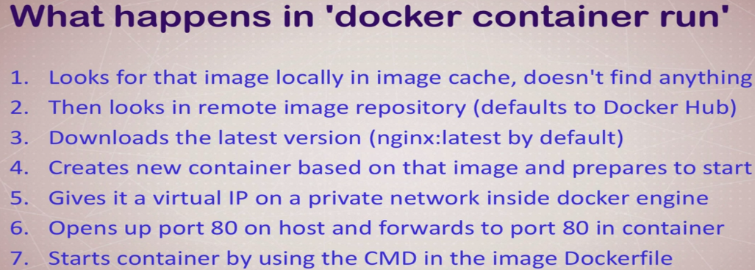

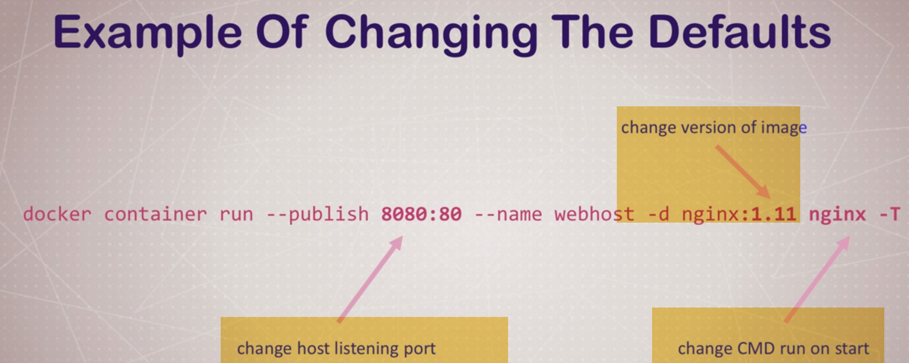

4.)012-container-vs.-vm-its-just-a-process

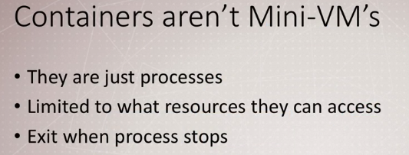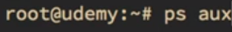

You can see this on host process running with different processID, because of security layers.

🡪Windows Containers  
(Windows Containers: Docker Is No Longer Just Linux )

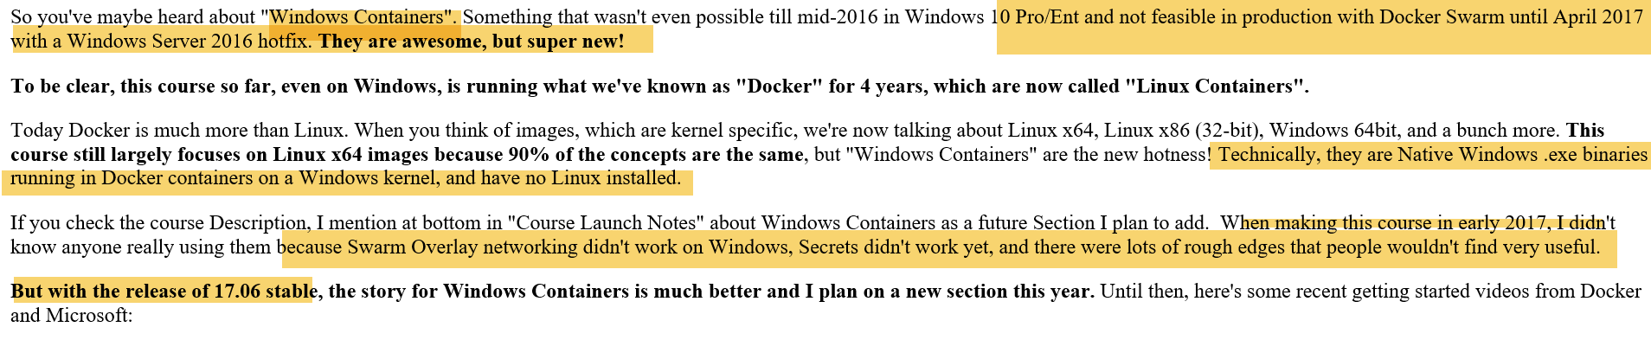

-🡪 014-assignment-manage-multiple-containers:

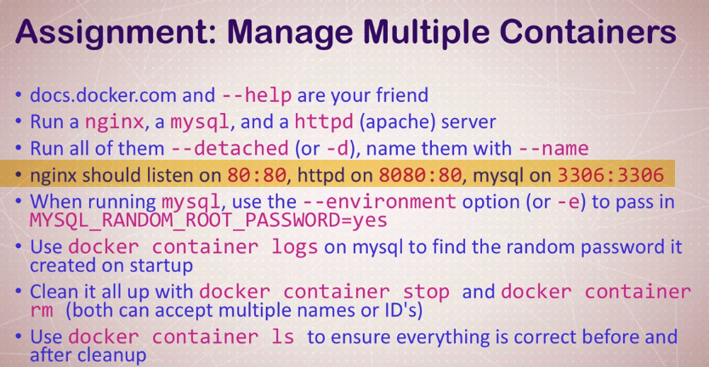



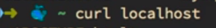

**🡪016-whats-going-on-in-containers-cli-process-monitoring**

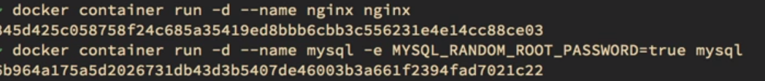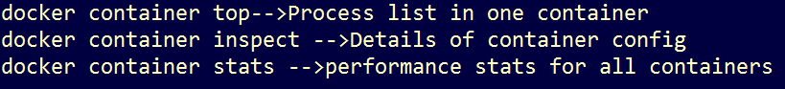

**🡪017-getting-a-shell-inside-containers-no-need-for-ssh**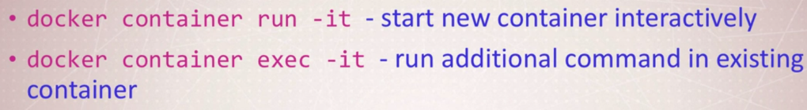





**-🡪 018-docker-networks-concepts-for-private-and-public-comms-in-containers**

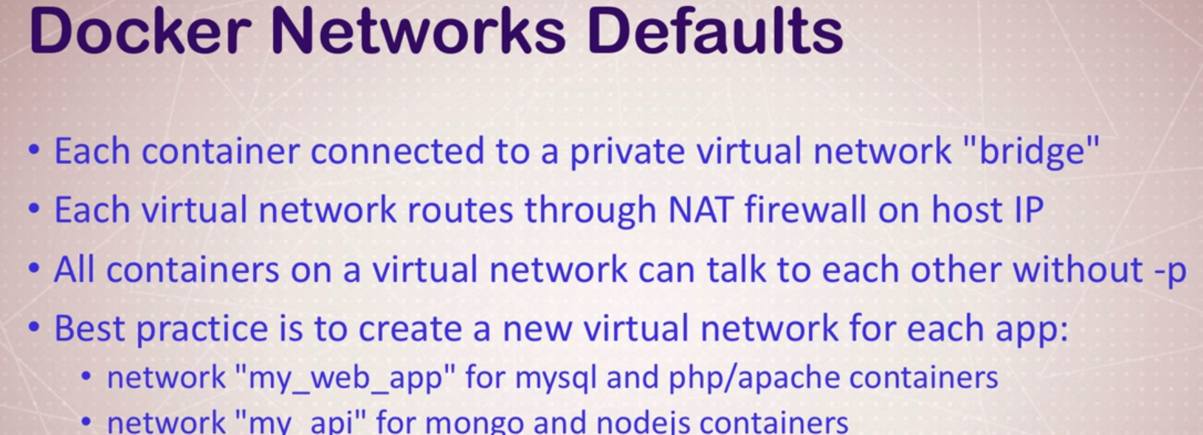 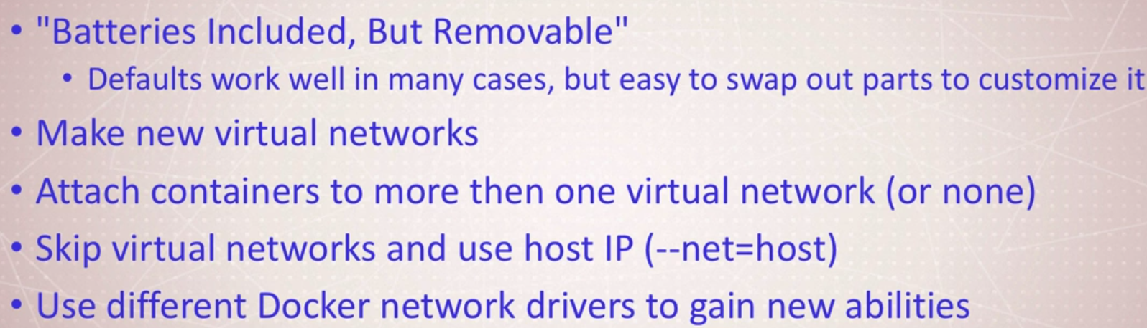

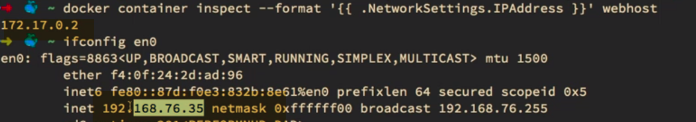

 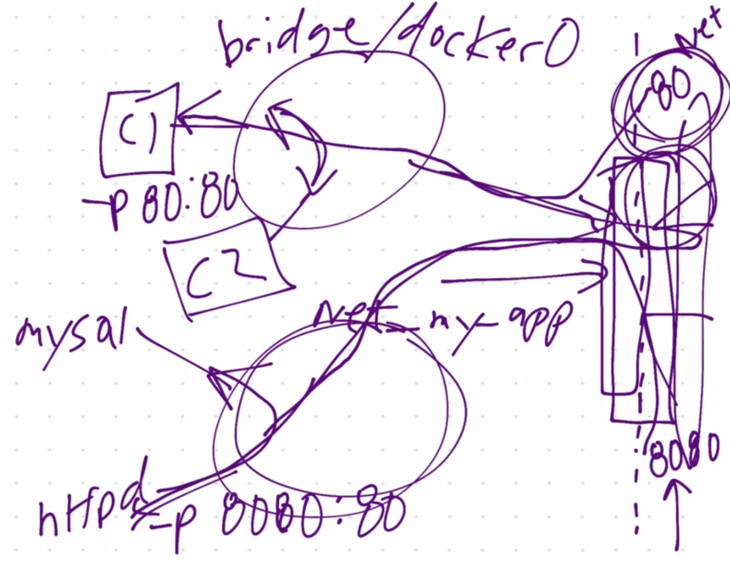

**020-docker-networks-cli-management-of-virtual-networks**

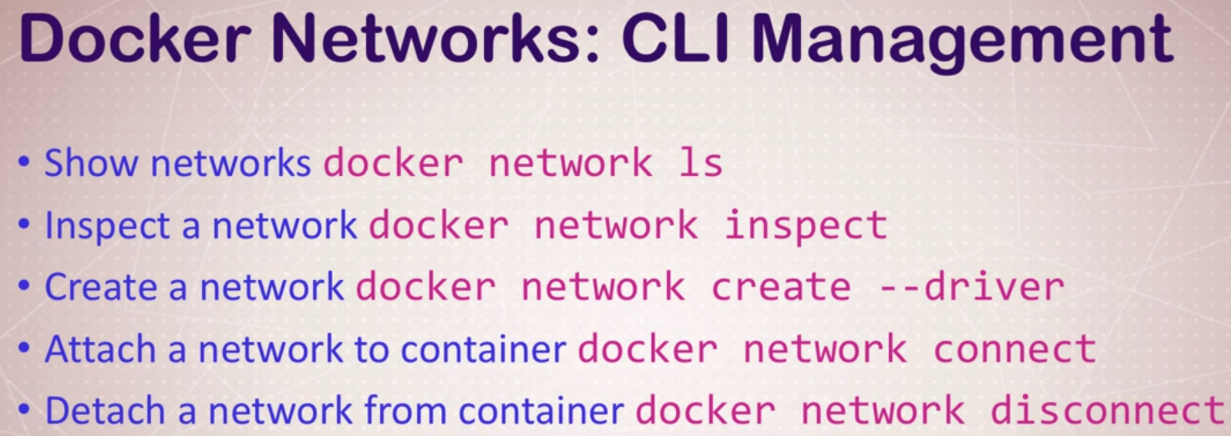

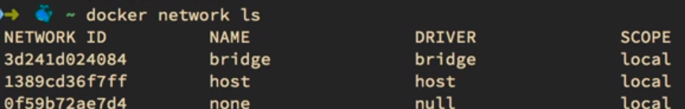

Bridge -🡪 Docker0🡪Default🡪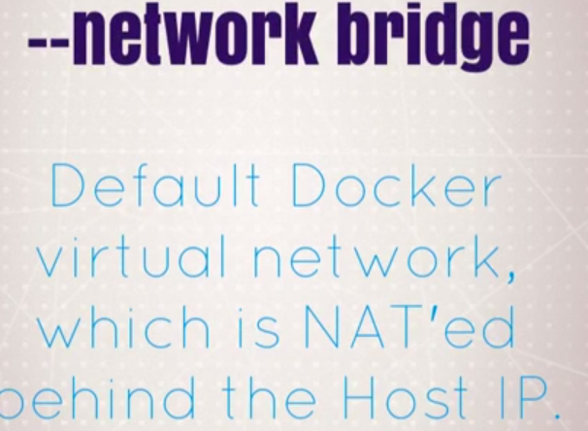

Host🡪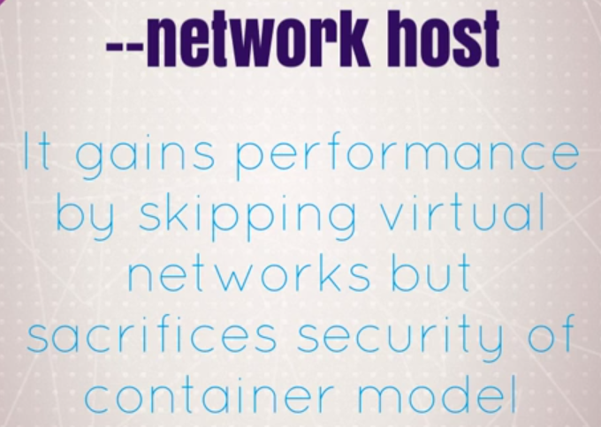

Skip Virtual networks and attaches directly to host interface.

None: 🡪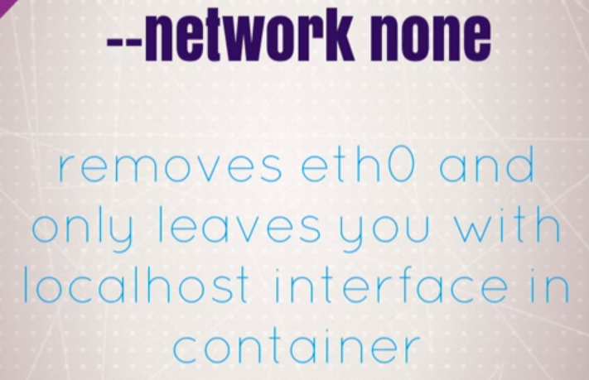

Not attached to anything

-🡪 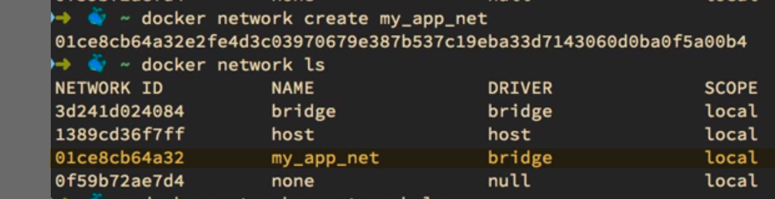

Creates network with Driver as Bridge... 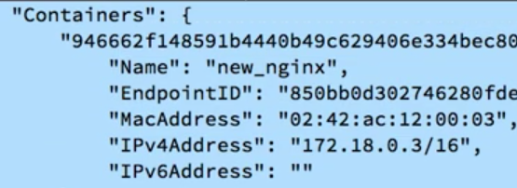🡪On new n/w with IP: 172.18(next subnet)